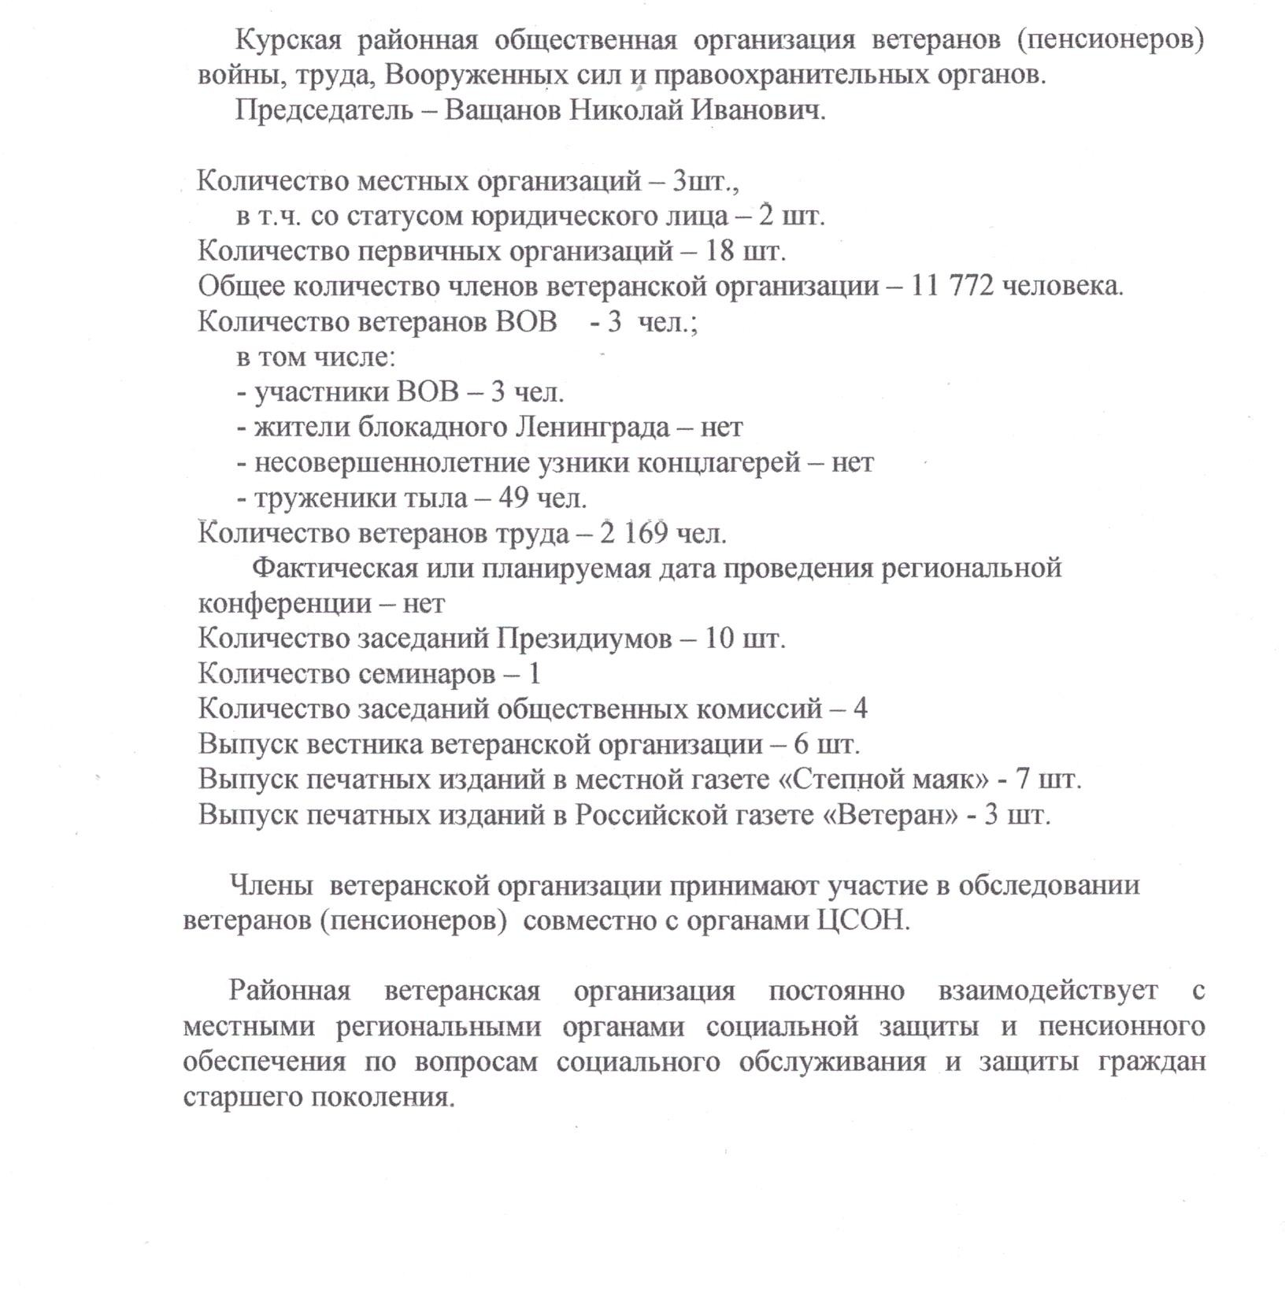
_ h

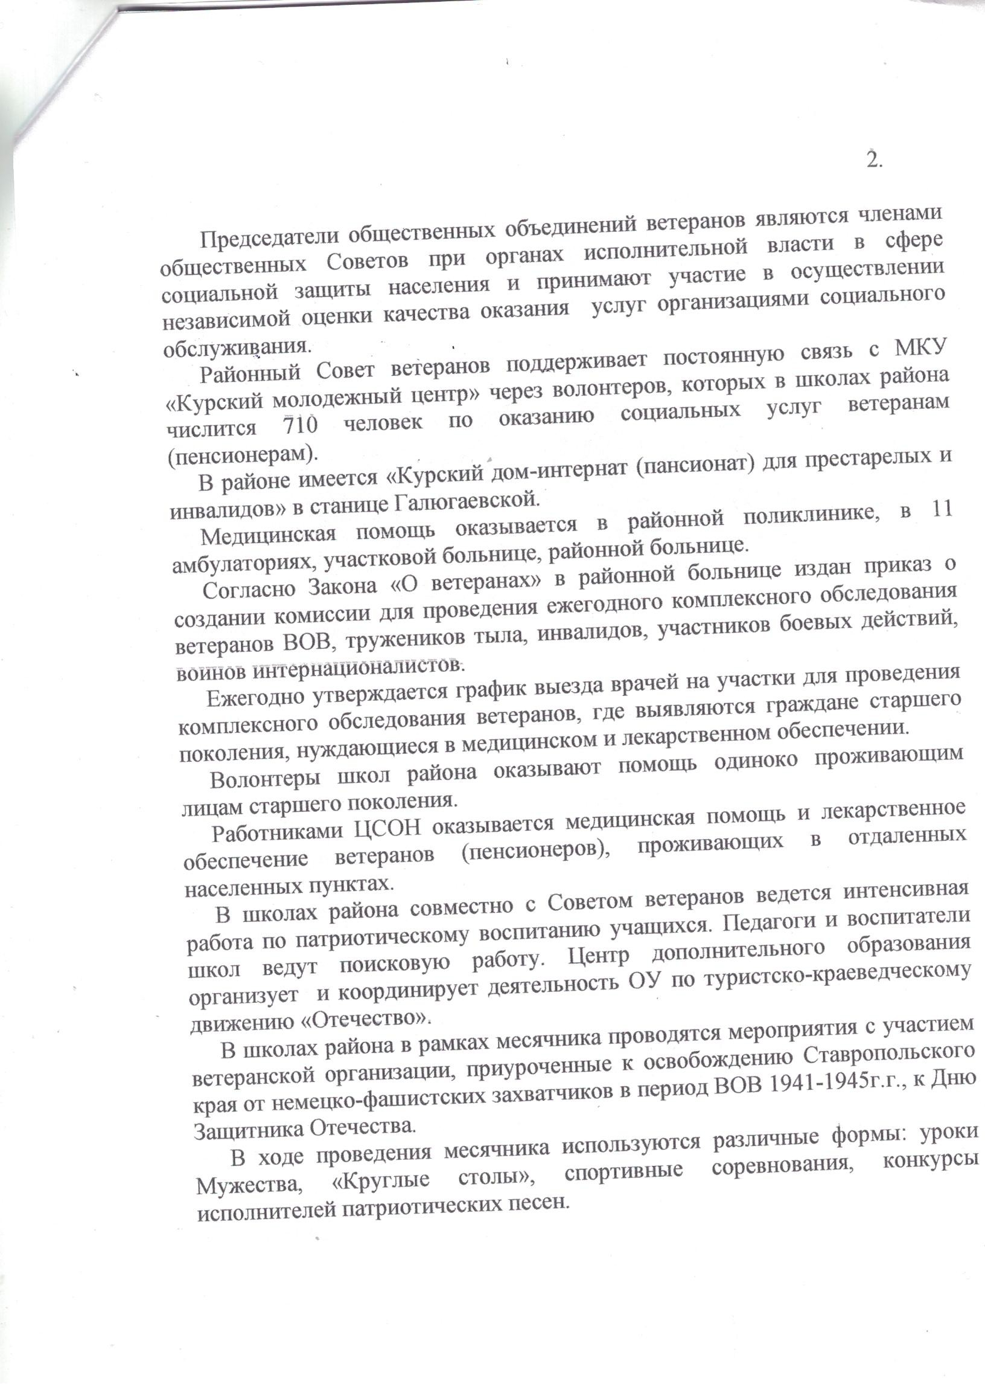
_ (JycBB_KnJn Hoeowooucoyu3TaB_pmpJm BcK_aJTKlecBHpTmT_ao BnpoaeoaalM_pea_o_oaJTywJtmJJn_Jn_raaH_yH_locB6Jn_eneeeT_u HoH_ocKHao_omno3TTHyTK_ccBHBBHy HyatbHHoKple6)Tpcpe)Hlm0ec_B7eJAolo1o _e_uxTBpcaKKy)Mr_pJu_ylo(Kb(a

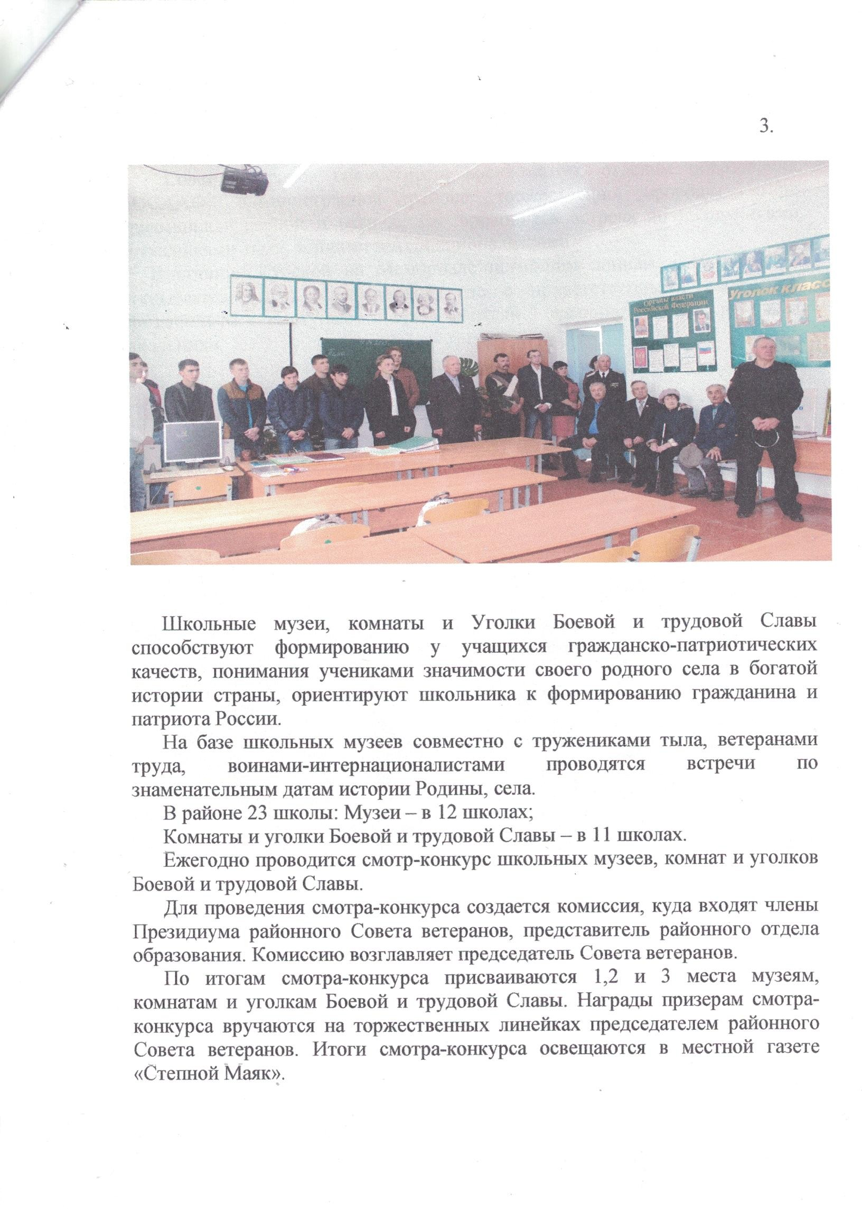
_ / t 0_0 _r t_ _G] 0 0 x_0cv ct c0_n0w0h c >_?_n_ x _□□□□□□□□□□□□□□□□□□□□□ _ _' _ ,,,,,,,_ ,,,,n,,,,,,,, _ ,_ _, ,-_ ''%□□□
. ,"'_q;Mc_"_;
_ _m;_'□ _

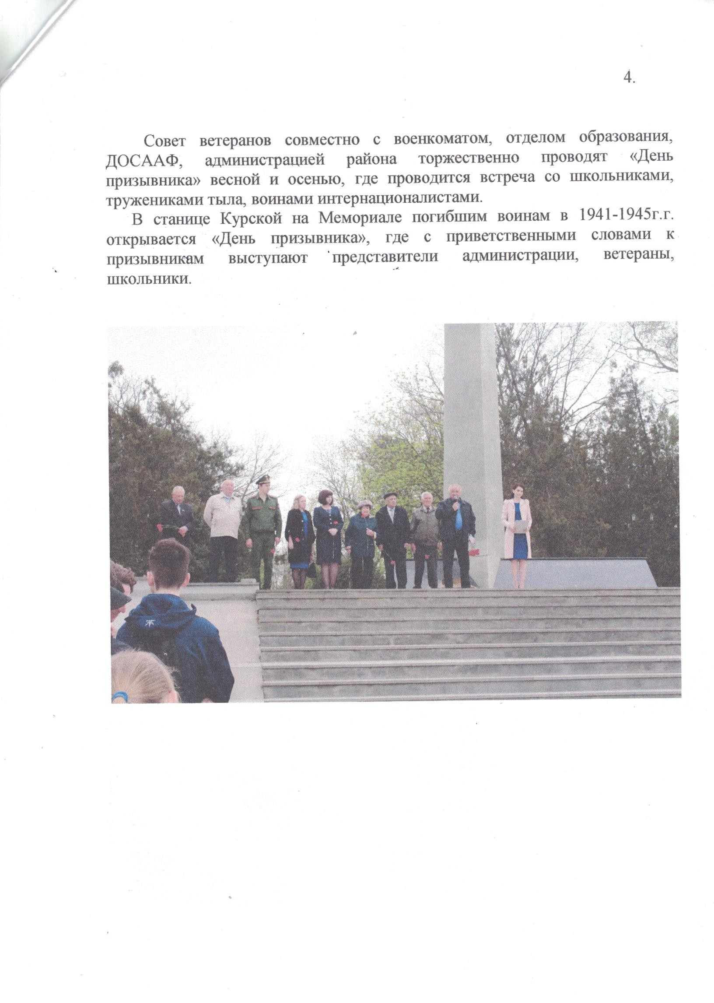
r o ?0h r 0 0 y J p_t c c? L vq 0_c 0 oxs 0 0 o_?_n? 0_s r
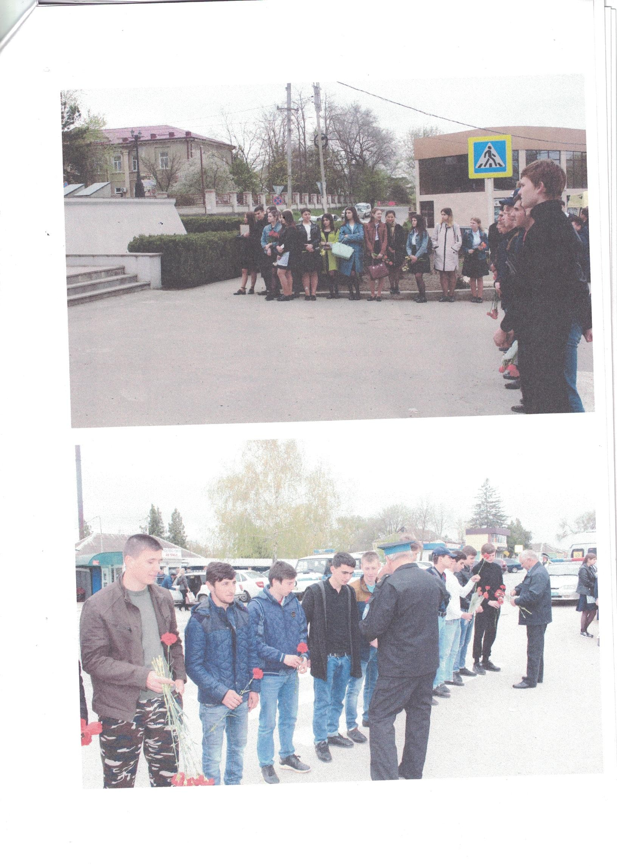
_t _p _0 ? ? 0c m 1_ t_r gx ? 0_0 0_o v ? ? ?9 u 3 ? ? q%Jm r 0 00w_0 l tl g 0 e ?_0 0 p
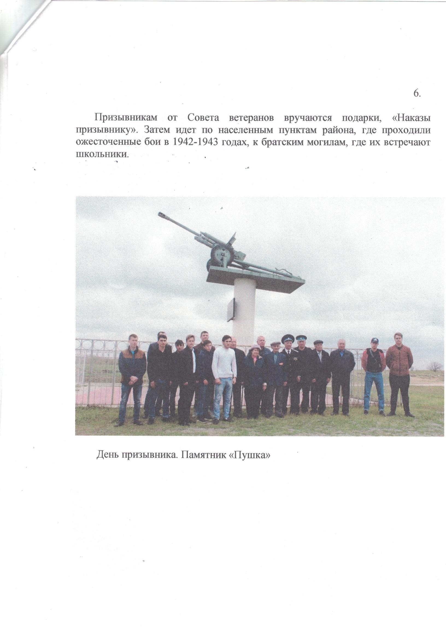
o c_; t e c c _c Jg p m _ 00 ? r? c 00 r n D00 ? c r t c ? ? n 0 0 n p ?_? c p ? ve u r r \

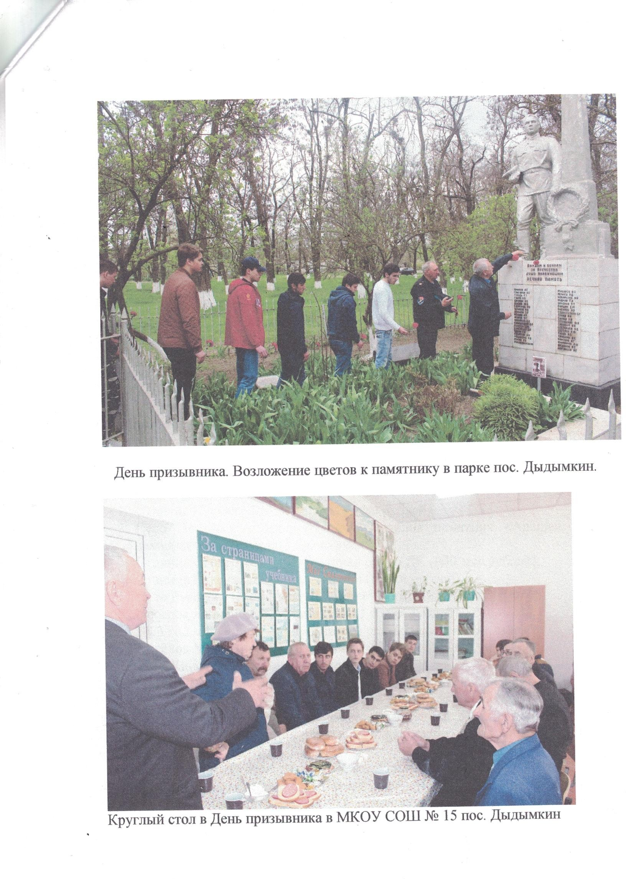
_n 0n0 ? u p_u_y ?r c c r c7 ?0_q p0 rg x 0c_n_0 0 00 q ? 0t J ? ?_%_?e 0e3 t4_0 ? t_? ? 0_e eJ t 0 t cJ
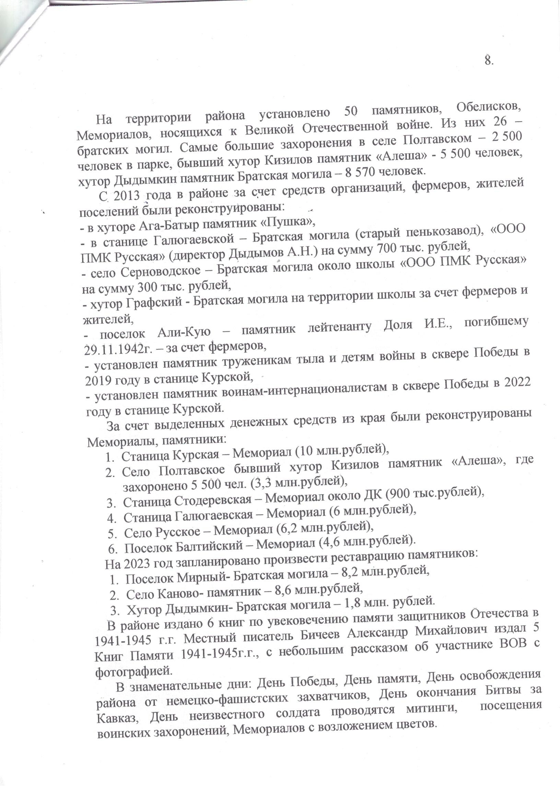
2_2_Bx Bc9_oyyeyx_c_ncc_JTcye9l2T_T33o4s6T1ooTIJta_a2cal_pt ar_po_eH_He0Hcocycp3_cc9cTucJn_noro Aq_ca_eeT4t4eBToTBep3yx0cpoaayJTeT2Jn AKJrE_aJn_KaoceHco Br eeor aKg_eperoM_HyoJrcJn o BpcB_T4A4JEcAn)To_obH )oyTna6aa
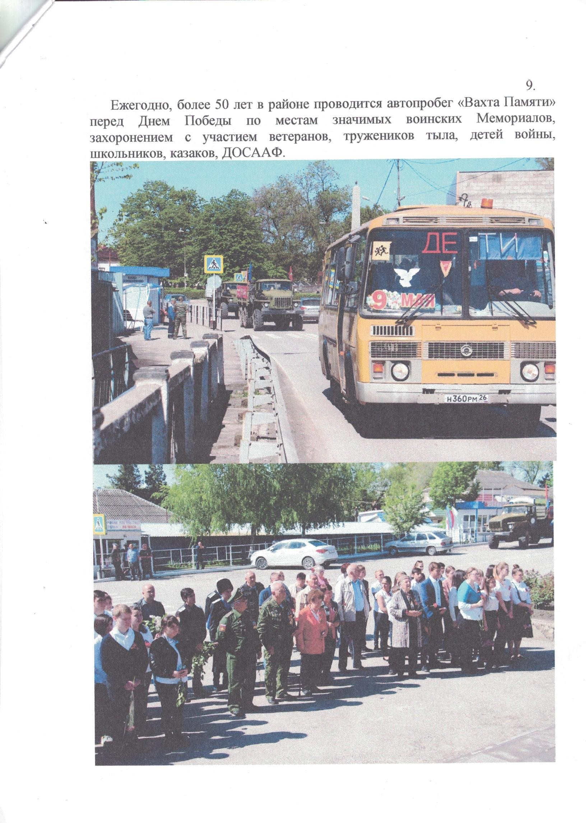
? 0 p_0 h0 _?0_u 0u , 0_? , ?_0_0_c ?c c J%% ' t J 9 y ? 9 t ?df_n 0 0_ _1 ? u_t?J 0 ? J%l 1% 0_c7 g_tt? ?

